

LICENSURE EXAMINATION FOR PROFESSIONAL TEACHERS
SEPTEMBER 20, 2026

GURONG PINOY: GENERAL EDUCATION REVIEWER
SOCIAL SCIENCE REFRESHER
(Session 6: May 11, 2026)

1. What was the family surname originally used by Rizal’s family?
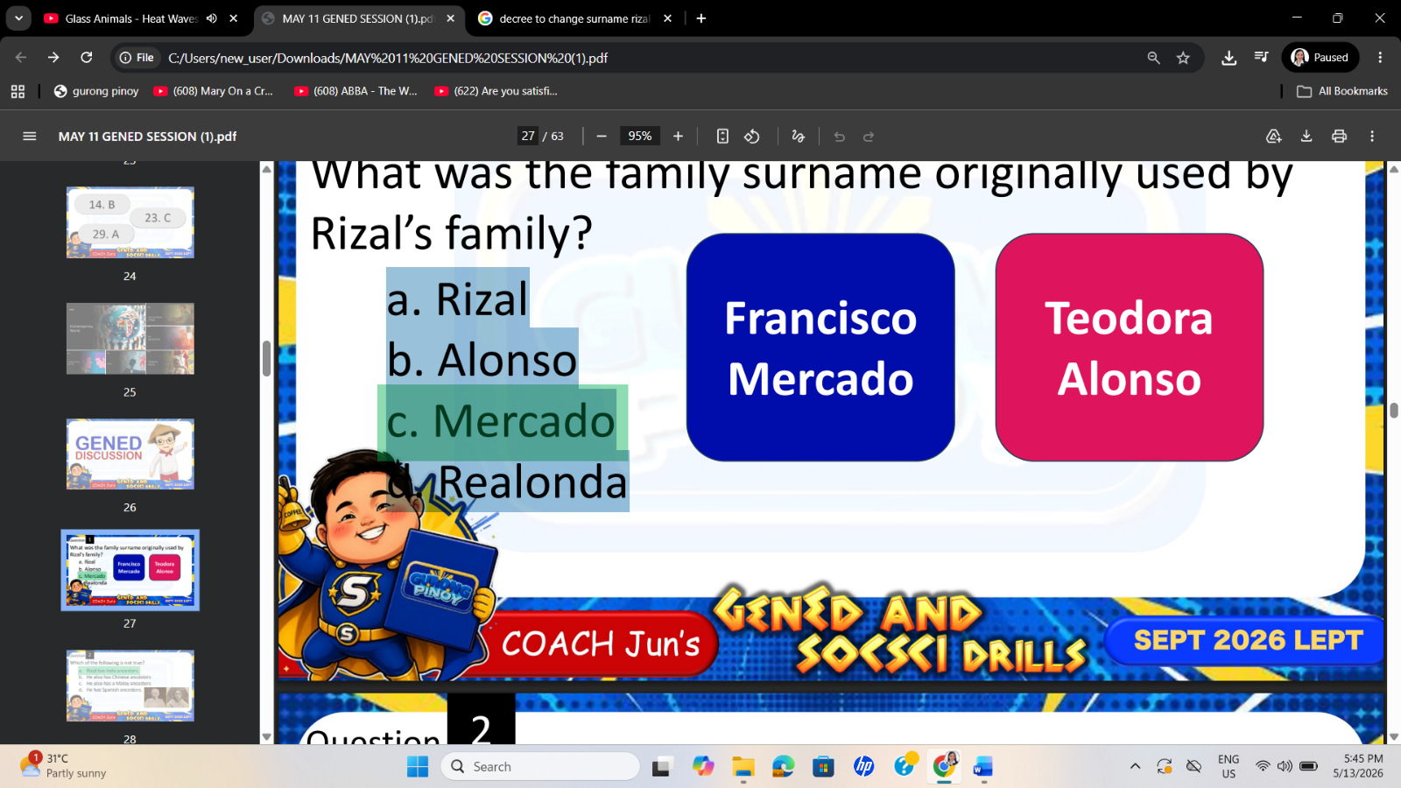
- Rizal
- Alonso
- Mercado
- Realonda

MERCADO: Market

RIZAL: Green field
The surname "Rizal" is derived from the Spanish word ricial, which means a "green field," "second crop," or "pasture," representing a "green field ready for harvest". It was adopted by the family of Philippine national hero Jose Rizal, who was originally named Mercado, to avoid Spanish suspicion and represent their agricultural roots.

CLAVERIA DECREE: change surname
The Rizal family adopted "Rizal" as a secondary surname due to the Clavería Decree of 1849, a Spanish colonial law mandating Filipinos to adopt new, standardized surnames from a provided catalog to improve census records and tax collection.

2. Which of the following is not true?
- Rizal has Indo ancestors
- He also has Chinese ancestors
- He also has a Malay ancestors
- He has Spanish ancestors.


3. He was the priest who baptized Rizal.
- Fr. Jose Bech
- Fr. Pedro Casanas
- Fr. Pablo Ramon
- Fr. Rufino Collantes

FR. RUFINO COLLANTES
He was the parish priest of Calamba who baptized Jose Rizal on June 22, 1861, three days after his birth. During the ceremony, Father Collantes remarked on Rizal's large head and told his family to take care of him, noting he would become a great man.

FR. PEDRO CASANAS was Rizal's godfather, not the priest who performed the baptism.

4. Who was the eldest sibling of Rizal?
- Saturnina Rizal
- Narcisa Rizal
- Olympia Rizal
- Lucia Rizal
- Saturnina
- Paciano
- Narcisa
- Olympia
- Lucia
- Maria
- Jose
- Concepcion
- Josefa
- Trinidad
- Soledad

S | P | N | O | L | M | J | C | J | T | S

5. Where did Rizal continue his early formal education?
- Biñan
- Manila
- Cebu
- Davao

6. Who was Rizal’s favorite professor in Ateneo?
- Pio Pi
- Jose Bech
- Vicente Belaguer
- Francisco de Paula Sanchez

FRANCISCO DE PAULA SANCHEZ: favorite teacher of Rizal
JOSE BECH: most hated teacher of Rizal

7. In his poem, “The Intimate Alliance Between Religion and Good Education”, Rizal showed the importance of religion in education. Which of these is a valid main topic for the poem?
- Education without God is not true education
- Religion without education is not a true education
- Education without God is allowable
- Religion without education is allowable

8. Which of Rizal’s works is a play?
- Junto al Pasig
- Mi Ultimo Adios
- Noli Me Tangere
- El Filibusterismo

JUNTO AL PASIG
It is a one-act play (or zarzuela) written by José Rizal in 1880. He composed it in Spanish at the request of the Jesuits to be performed for the Feast Day of the Immaculate Conception.

9. What course did Rizal initially take at the University of Santo Tomas?
- Medical Technology
- Philosophy and Letters
- Engineering
- Education


10. The line “fair hope of the fatherland” in one of Rizal’s poems was referring to the Filipino
- Leader
- Hero
- Athlete
- Youth

The line “fair hope of the fatherland” (“bella esperanza de la patria mía”) in Jose Rizal’s poem “A LA JUVENTUD FILIPINA” (TO THE FILIPINO YOUTH), written in 1879, refers to the Filipino Youth. Rizal, at 18 years old, wrote this poem to inspire young Filipinos to use their talents in arts and sciences to uplift the nation and break free from the chains of ignorance and oppression.

11. At which university in Spain did Rizal study medicine?
- University of Barcelona
- Universidad Central de Madrid
- University of Seville
- University of Valencia

12. Which country did Rizal visit to specialize in ophthalmology under Dr. Otto Becker?
- France
- Germany
- England
- Italy

GERMANY
Dr. Jose Rizal traveled to Heidelberg, Germany, in February 1886 to advance his training in ophthalmology. He worked as an assistant at the University Eye Hospital under the direction of DR. OTTO BECKER, a renowned German professor of ophthalmology. Rizal pursued this medical specialization specifically to treat and cure his mother's advancing blindness.

FRANCE
While Rizal did live in Paris, France, to study ophthalmology, he trained there under the prominent French oculist DR. LOUIS DE WECKER.

ENGLAND
Rizal stayed in London, England, primarily to boost his historical research and annotate ANTONIO DE MORGA'S SUCESOS DE LAS ISLAS FILIPINAS at the British Museum.

13. Conversant in several European languages, Rizal is described as
- Orator
- Debater
- Publicist
- Linguist

It is typically claimed that he was conversant in as many as 22 languages.

14. Rizal fought for freedom in a silent yet powerful way, expressing his fervent wish for the Philippines in his novels, poems, essays, and feature articles rather than the use of force or aggression. This is best described by the quote
- Give me liberty or give me death.
- The pen is mightier than the sword.
- To err is human, to forgive is divine.
- Death is better than a life of dishonor.

15. The heaven-sent financer of Noli Me Tangere is
- Rufino Collantes
- Valentin Ventura
- Pedro Casanas
- Maximo Viola

ME = Vea/ Viola: NOLI ME TANGERE = MAXIMO VIOLA
EL = VV ko (Eloy): EL FILI = VALENTIN VENTURA
Borrowed Php. 300 to produce 2k copies of the book.

TITLE: NOLI ME TANGERE
- Literal Meaning: The title Noli Me Tángere is a Latin phrase that translates to "TOUCH ME NOT" or "DO NOT TOUCH ME".
- Biblical Source: It originates from the Gospel of JOHN (20:17), where Jesus speaks these words to Mary Magdalene after His resurrection.
- Medical Metaphor: José Rizal, who trained as an ophthalmologist, used the phrase as a 19th-century medical term for an excruciatingly painful cancer of the eye or skin that was too sensitive to be touched.
- Social & Symbolic Meaning: Rizal used this medical concept to represent the "SOCIAL CANCER" infecting Philippine society under Spanish rule. It signified systemic corruptions—such as abuses by Spanish friars and the colonial government—that were so deeply rooted, sensitive, and taboo that people refused to speak of or "touch" them. Major English Translations
- The novel was originally written and published in Spanish in 1887. Because it is a cornerstone of Filipino nationalism, it has been translated into English multiple times, with each version reflecting different historical contexts and editorial goals:

Translation Title | Translator | Year | Key Characteristics & Context
An Eagle Flight | Anonymous adaptation | 1900 | The oldest known English adaptation, published in New York shortly after the U.S. took control of the Philippines.
The Social Cancer | Charles Derbyshire | 1912 | Highly literal and academic; it retains original Spanish and Tagalog terms to maintain local flavor. It leans heavily into Rizal’s medical metaphor of a societal disease.
The Lost Eden | Leon Ma. Guerrero | 1961 | A modernized and heavily stylized translation. Guerrero simplified local color, removed many European literary references, and adjusted the prose to sound smoother for 20th-century readers.
Noli Me Tangere | Ma. Soledad Lacson-Locsin | 1996 | Widely praised by historians and literary critics for being the most faithful to Rizal's original 19th-century Spanish prose, retaining his specific rhythm, wit, and cultural nuances.
Noli Me Tangere (Touch Me Not) | Harold Augenbraum | 2006 | Published by Penguin Classics to introduce the novel to a broader, global contemporary audience, featuring explanatory endnotes regarding Filipino and Spanish history.

CORE THEMES OF THE NOVEL
- Clerical Abuses & Hypocrisy: Exposure of the corruption, greed, and moral failings of Spanish friars (personified by characters like Padre Dámaso and Padre Salví) who used religion to exploit and control the local population.
- Education as Empowerment: Reinforcing the concept that enlightenment and education, rather than violent rebellion, are the primary tools for freeing a society from oppression.
- Colonial Mentality: Satirizing the desperation of certain elite Filipinos (like Doña Victorina) who abandoned their native heritage to frantically mimic Spanish customs.
- National Consciousness: Awakening a collective Filipino identity and sense of shared homeland out of a fragmented and oppressed colony.

TITLE: EL FILIBUSTERISMO
- Literal Meaning: The title EL FILIBUSTERISMO translates from Spanish to "The Subversion", "The Filibustering", or "THE REIGN OF GREED".
- Historical Definition: In the 19th century, a filibustero in the Philippines was a subversive, a political agitator, or a rebel who worked to disrupt Spanish colonial rule. It was a dangerous label used by authorities to mark reform-minded Filipinos for execution or exile.
- Dedicatory Meaning: José Rizal dedicated the novel to the memory of the GOMBURZA (FATHERS GOMEZ, BURGOS, AND ZAMORA), three Filipino priests falsely accused of mutiny and publicly executed by garrote in 1872.
- Symbolic Meaning: While Noli Me Tangere diagnosed the "social cancer," El Filibusterismo represents the desperate, violent reaction to that untreated disease. It symbolizes anger, disillusionment, and the terrifying temptation of bloody revolution when peaceful reform fails.
- Written in Spanish and published in Ghent, Belgium in 1891, El Fili is darker, more cynical, and more political than its predecessor. It has been translated into English under various titles:

Translation Title | Translator | Year | Key Characteristics & Context
The Reign of Greed | Charles Derbyshire | 1912 | The classic academic translation. It paired with his version of Noli and established the title "The Reign of Greed" in Philippine schools.
The Subversive | Leon Ma. Guerrero | 1965 | A highly readable, modernized translation. Guerrero updated the prose to make the political debates and revolutionary plots accessible to contemporary readers.
El Filibusterismo | Ma. Soledad Lacson-Locsin | 1997 | Highly regarded for literary fidelity. It preserves Rizal's original Victorian-era Spanish sentence structures, vocabulary, and satirical tone.
The Subversive (El Filibusterismo) | Harold Augenbraum | 2011 | Published by Penguin Classics. It features extensive footnotes explaining the complex 19th-century political landscape for a global audience.

CORE THEMES OF THE NOVEL
- The Failure of Peaceful Reform: The protagonist Simoun (a disguised, cynical Crisostomo Ibarra) abandons his old ideals of education and legal reform, turning instead to radical destruction.
- The Ethics of Revolution: The novel serves as a deep philosophical debate on whether a corrupt system can be justly overthrown through violence, ultimately warning that hate and blood only breed more monsters.
- Systemic Corruption and Greed: An intense critique of the absolute decay within the colonial government, the military, and the church hierarchy, all driven purely by wealth and power.
- Youth and the Future: Highlighted in the famous final monologue by Padre Florentino, the novel challenges the Filipino youth to make themselves worthy of freedom through purity, sacrifice, and moral integrity.

16. In Noli Me Tangere, this character hated being a Filipino; that she married a Spaniard. She wore European dresses and covered her “kayumanggi” skin with thick makeup.
- Donya Consolacion
- Donya Victorina
- Maria Clara
- Sisa

COLONIAL MENTALITY

17. El Filibusterismo is the sequel of Noli Me Tangere and like the first book, it was written in Spanish. To whom did he dedicate this second novel?
  - To his beloved parents
  - To the suffering Filipino people
  - To the executed Filipino priests
  - To his love, Leonor Rivera

18. What is the symbolism of Bapor Tabo in the first chapter of El Filibusterismo?
  - Social class divide
  - Water pollution in Pasig River
  - Arrival of the Americans
  - Love of the Spanish for luxury

19. In El Filibusterismo, the nitro-glycerin explosive was placed in Simoun’s
- Tomb
- Lamp
- Oven
- Car

20. The unfinished literary work of Jose Rizal was entitled
- Makamasa
- Makamisa
- Makimasa
- Makibaka

21. What did Rizal do with the Antonio de Morga’s book entitled, “Succesos de las Islas Filipinas” at the British museum?
- Criticize it
- Borrowed and brought it home
- Copied, annotated, and published it
- Vandalized and burned it

22. Jose Rizal’s essay and Marcelo Del Pilar’s various writings were published in the propaganda newspaper
- La Patria
- La Solidaridad
- La Frailocracia
- La Independencia

23. According to Rizal, what is one cause of Filipino indolence?
- Natural laziness
- Climate only
- Colonial oppression
- Lack of intelligence

24. What was Rizal’s tone in the essay “Filipinas dentro de cien años” / A Philippine Century Hence?
- Humorous
- Predictive
- Emotional
- Fictional

25. When Rizal returned to the Philippines after his second travel abroad, he decided to organize a national socio-civic organization. This was the
- Propaganda movement
- La Independencia
- KKK
- La Liga Filipina

26. What is Rizal’s teaching approach to his students in Dapitan?
- Authoritarian
- Strict
- Progressive
- Traditional

27. Who was Rizal’s companion in Dapitan?
- Leonor Rivera
- Segunda Katigbak
- Josephine Bracken
- Trinidad Rizal

28. What was the name given to the baby of Rizal but due to a twist of fate, only lived for three hours?
- Jose
- Teodoro
- Marcelo
- Francisco

29. Who was one of the Katipunan leaders sent by Bonifacio to Dapitan to inform Jose Rizal of their plan for the upcoming arm revolution?
- Dr. Mariano Alvarez
- Dr. Romeo Marinez
- Dr. Miguel Antalan
- Dr. Pio Valenzuela

Andres Bonifacio sent DR. PIO VALENZUELA to Dapitan in June 1896 to inform Jose Rizal about the Katipunan's planned armed revolution against Spain and to seek his support. Valenzuela, a close friend of both Rizal and Bonifacio, served as an emissary to consult the exiled hero, traveling with a blind companion named RAYMUNDO MATA to conceal the true purpose of his visit.

30. Who was the Governor-General who ordered the death of Rizal?
- Ramon Blanco
- Eulogio Despujol
- Rafael Izquierdo
- Camilo Polavieja

31. The first line of this poem written by Rizal was, “Adios, Patria Adorada”
- Bagong Lipunan
- Huling Paalam
- Sa Aking mga Kabata
- Huwag mo akong Salingin

32. What tone is present in the poem Mi Ultimo Adios?
- Angry
- Fearful
- Peaceful
- Humorous

33. How was Rizal executed?
- Hanging
- Firing squad
- Poisoning
- Imprisonment

34. In this university, Rizal obtained his licentiate in Medicine
- University of Sto. Tomas
- Ateneo de Manila University
- Universidad Central de Madrid
- University of Heidelberg

35. Arrange the following events chronologically from the first to the last
- Execution of GomBurZa
- Formal education in Ateneo and UST
- Execution by firing squad in Bagumbayan
- Birth in Calamba
- Completion of Noli Me Tangere and El Filibusterismo
- II, IV, I, II, V
- IV, I, II, V, III
- IV, II, V, I III
- II, I, IV, V, III

